E27 LED BULBS
ITEM NO:VT-2007;WATTS:7W
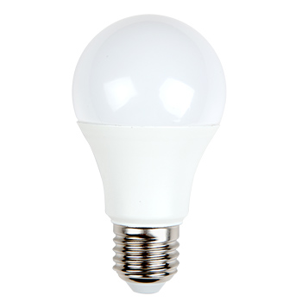
Item No: | VT-2007
SKU Code | 4377:4500K (Day White)
Type | A60
Base | E27
Real Watts | 7W
EQ. Watts | 40W
Voltage | 220-240V
Input Frequency | 50Hz
Input Efficiency | 67lm/w
Lumen(lm) | 470lm
PF | >0.5
RA | >80
Color Temperature | 3000K,4500K,6000K
Beam Angle | 200’D
LED Chip | SMD
Driver | Non Isolated Constant Current power
Protection Class | IP20
Body Material | Thermal Plastic
Dimmable | No
Unit size | Φ60mm*108mm
Life Time | 20000hrs
Operation Temperature | -25 ~50’C
Applicable Environment | Indoor Lighting, Used in Home down light, Stairwell lighting.

