PRISMATIC FITTING
ITEM NO: VT-8020; WATTS: 20W
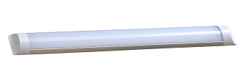

Item No: | VT-8020
SKU Code | 4991:4500K
Real Watts | 20W
EQ. Watts | 100W
Voltage | AC:200~240V
Input Frequency | 50Hz
Input Efficiency | 80lm/w
Lumen(lm) | 1600lm
PF | >0.9
CRI | >80
Color Temperature | 3000K,4500K,6000K
Beam Angle | 110’D
LED Chip | SMD
Protection Class | IP20
Body Material | Aluminum+Plastic
Dimmable | No
Unit size | L:600x75x25mm
Life Time | 20000hrs
Operation Temperature | -25 ~50’C
Applicable Environment | Indoor Lighting, Used in Home down light, Stairwell lighting.

