ITEM NO:VT-1864;WATTS:12W
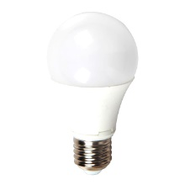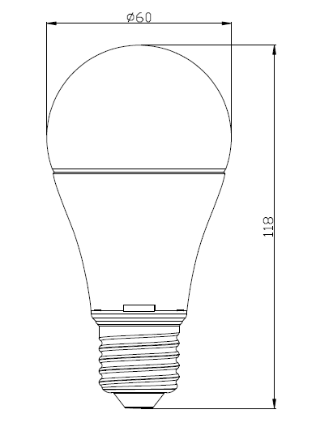
Item No: | VT-1864
SKU Codes | 4228:3000K
Base | E27
Real Watts | 12W
EQ. Watts | 75W
Voltage | 100~240V
Input Frequency | 50/60Hz
Input Current | 72ma
Input Efficiency | 87lm/w
Lumen(lm) | 1055lm/w
PF | >0.5
CRI | >80
Color Temperature | 3000K,4500K,6000K
Beam Angle | 200’D
LED Chip | SMD 2835
LED Qty | 27
Driver | Constant current non-isolated driver
Protection Class | IP20
Body Material | Plastic
Dimmable | No
Unit size | 60mmx118mm
Life Time | 20000hrs
Operation Temperature | -25 ~50’C
Applicable Environment | Indoor Lighting, Used in Home down light, Stairwell lighting.

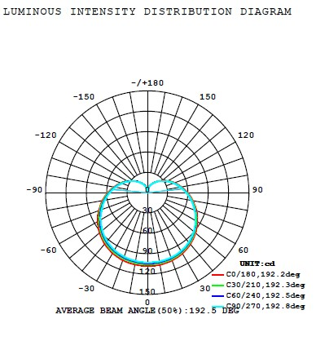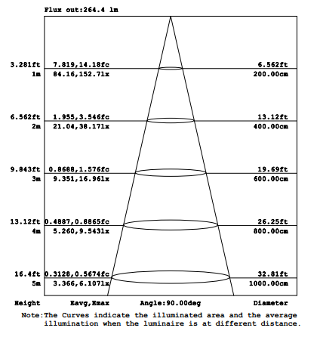

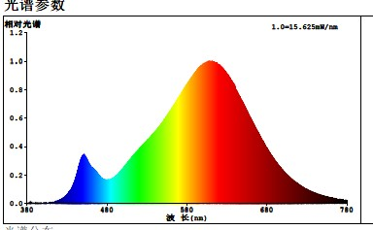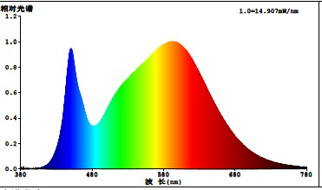
Color Temperature:2700KColor Temperature:4000K
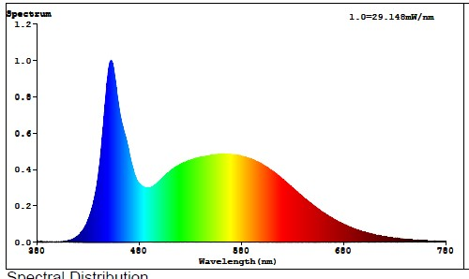
Color Temperature:6500K

Instruction Manual：
Installing please following below steps:
- Please note to cut off the power supply before replacing the lamp to prevent electric shock or lamp burning, choose to install to correspondingly lampholders
- When try to tighten or take off the bulb, please clench radiator body by finger as shown below :

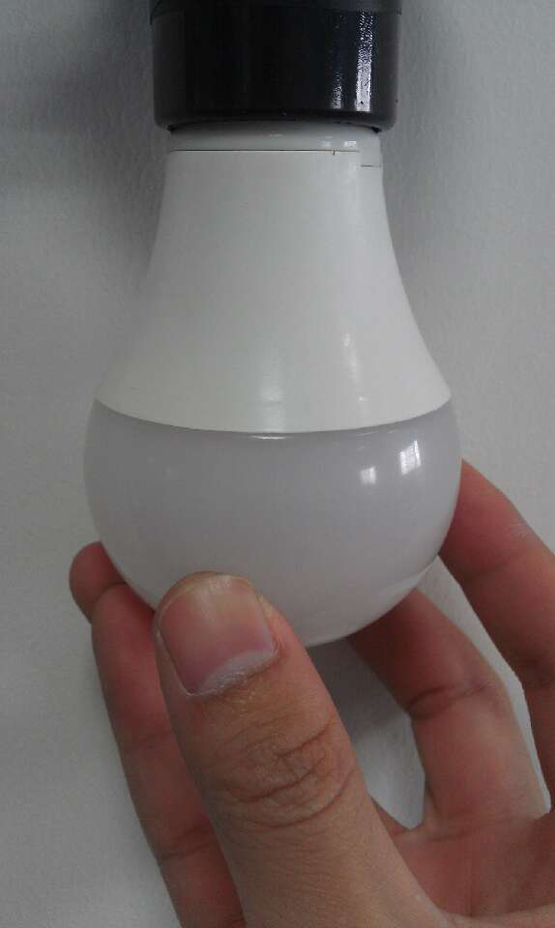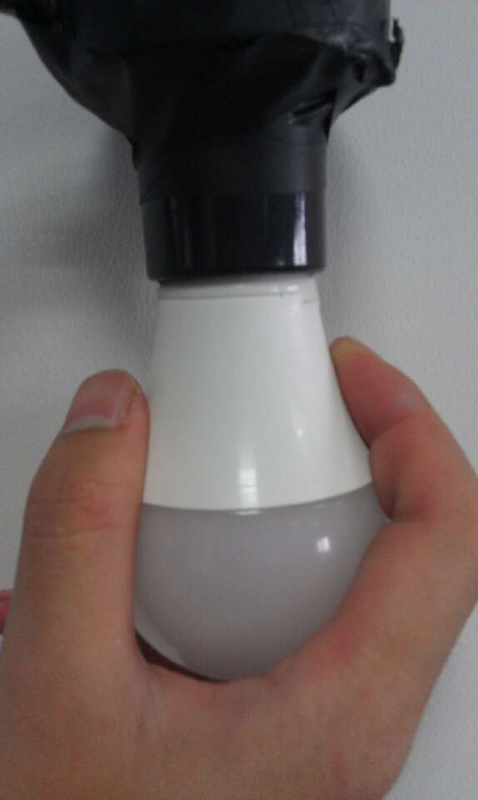

- When need to take off the bulb ,please wait 20minutes after turning off,so as not to burn your fingers

